**SOFTWARE ENGINEERING LAB ASSIGNMENT**

**SUBMITTED TO: PROF K N MISHRA**

SUBMITTED BY:-

ANAMIKA THAKUR

BTECH/60080/19

IT 305 SOFTWARE ENGINEERING

Question1:

Construct/Develop the Sequence diagrams for your selected

modules using Visual Paradigm Software Tool.

MODULE 1 : SEMESTER OFFICE

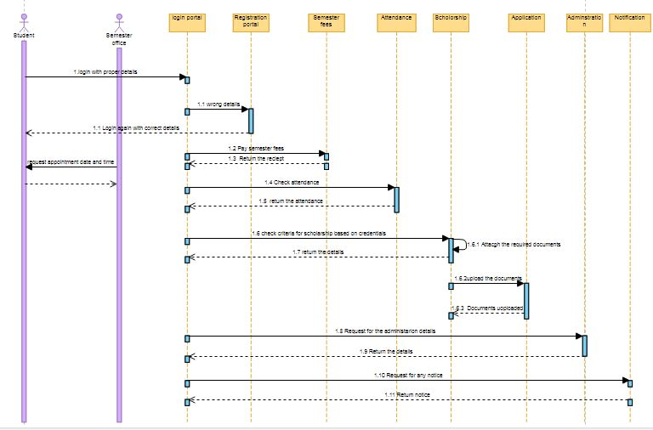

***FIG 1***

MODULE 2 : GIRLS HOSTEL

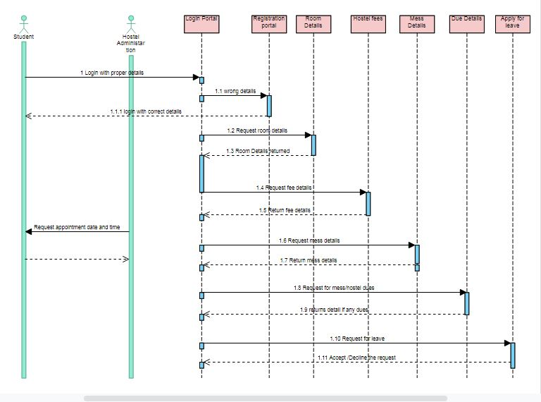

*FIG 2*

MODULE 3: CSE DEPARTMENT

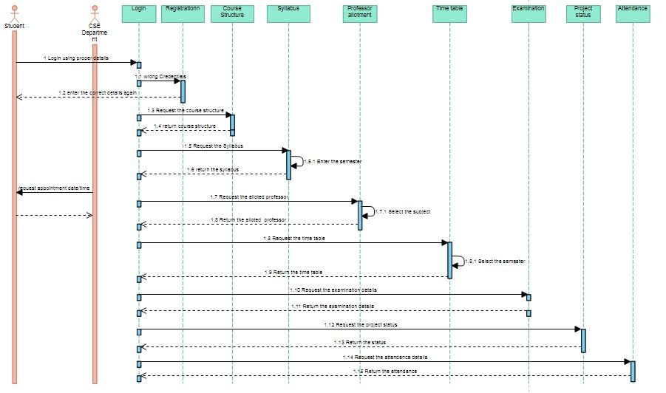

*FIG 3*

MODULE 4 : ERP

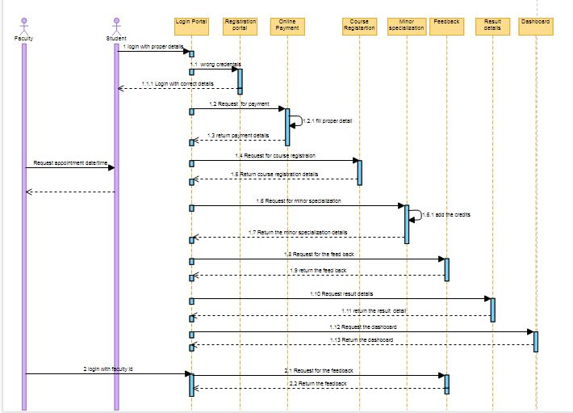

*FIG 4*

5. SEQUENCE DIAGRAM OF ALL MODULES COMBINED:-

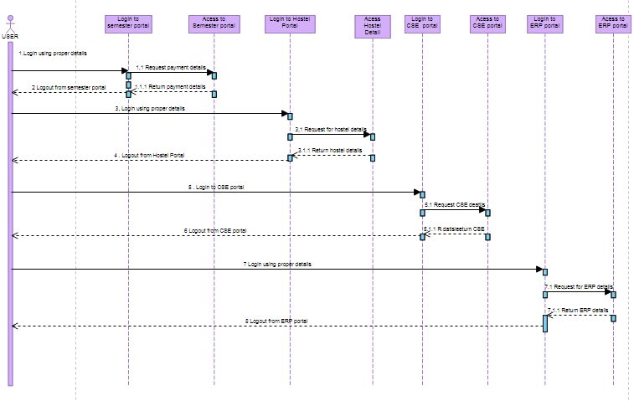

Question 2: Develop the Class diagrams including association, aggregation,

generalization and realization (SuperClass-Subclass) relationships for your

selected modules using Visual Paradigm Software Tool.

**MODULE 1: SEMESTER OFFICE**

**1.2 INDEPENDENT CLASS DIAGRAM**

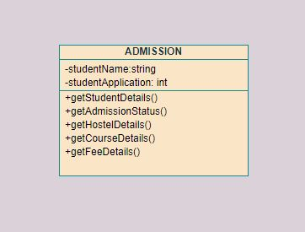

*5 Admission class*

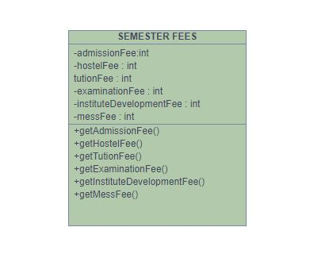

1. *fees class*

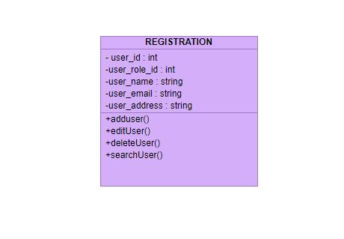

1. *Registration class*

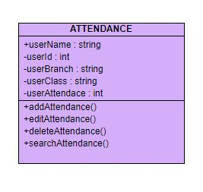

*FIG 8 Attendance class*

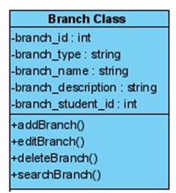

*FIG 9 Branch class*

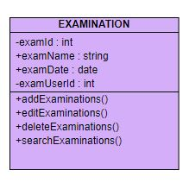

*FIG 10Examination class*

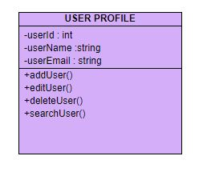

*FIG 11 User class*

**1.3 SUPER-SUB CLASS SUBCLASS DIAGRAM**

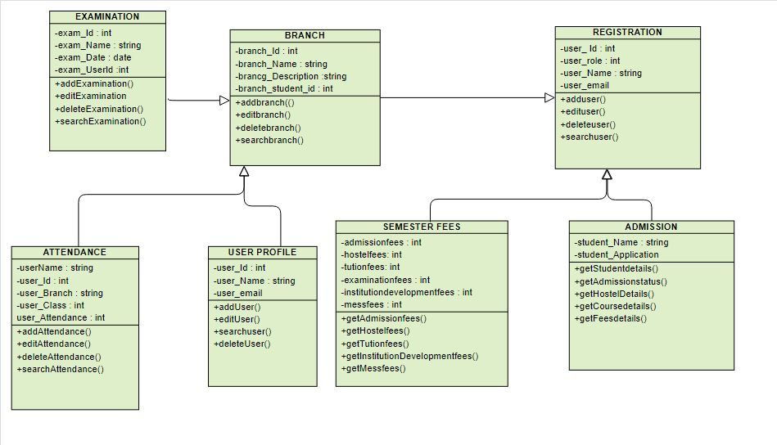

*FIG .12*

**1.4 ASSOCIATION DIAGRAM**

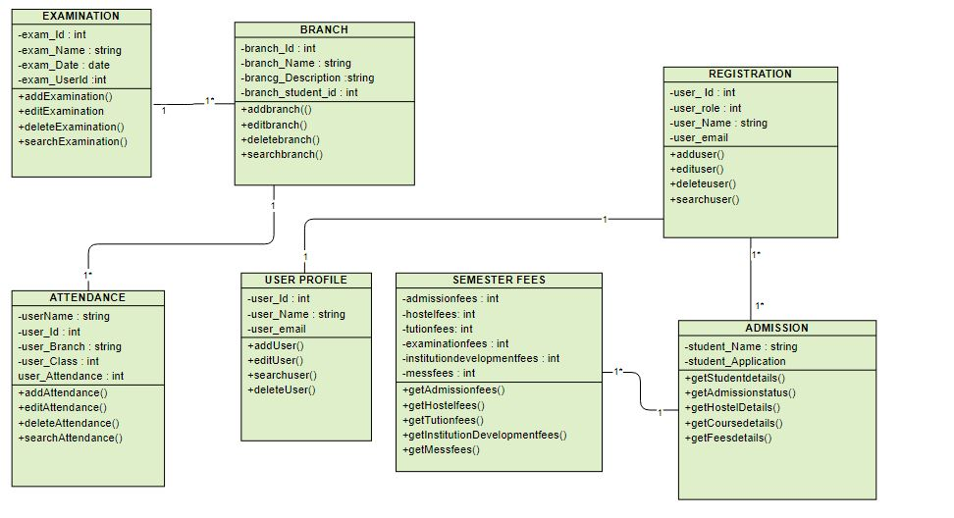

*FIG 13*

**1.5 AGGREGATION DIAGRAM**

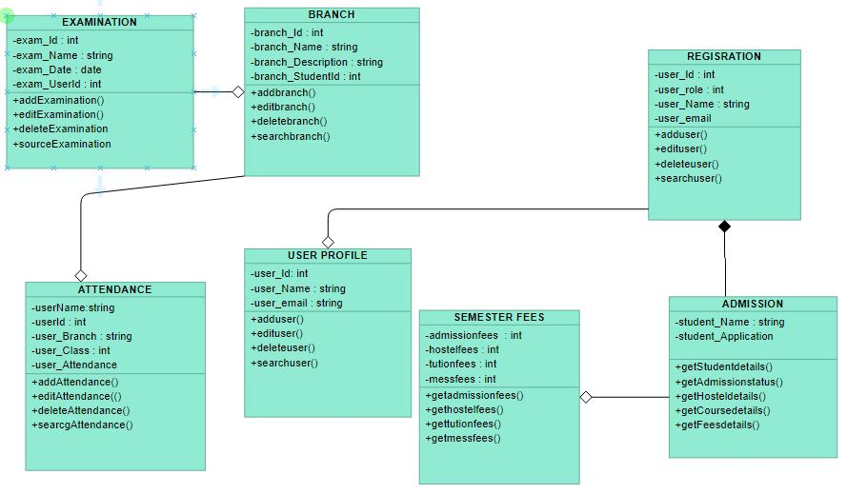

**MODULE 2 GIRLS HOSTEL**

**2.2 INDEPENDENT CLASS DIAGRAM**

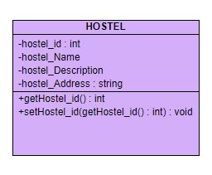

*FIG 14 HOSTEL CLASS*

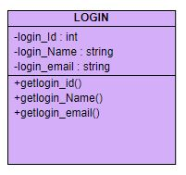

*FIG 15 LOGIN CLASS*

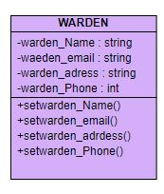

*FIG 16 WARDEN CLASS*

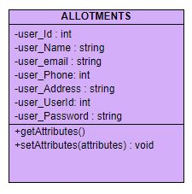

*FIG 17 ALLOTMENT CLASS*

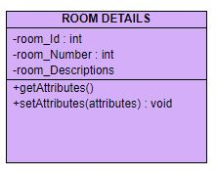

*FIG 18 ROOM DETAIL CLASS*

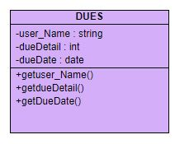

*FIG 19 DUES CLASS*

**2.3 SUPER-SUB CLASS DIAGRAM**

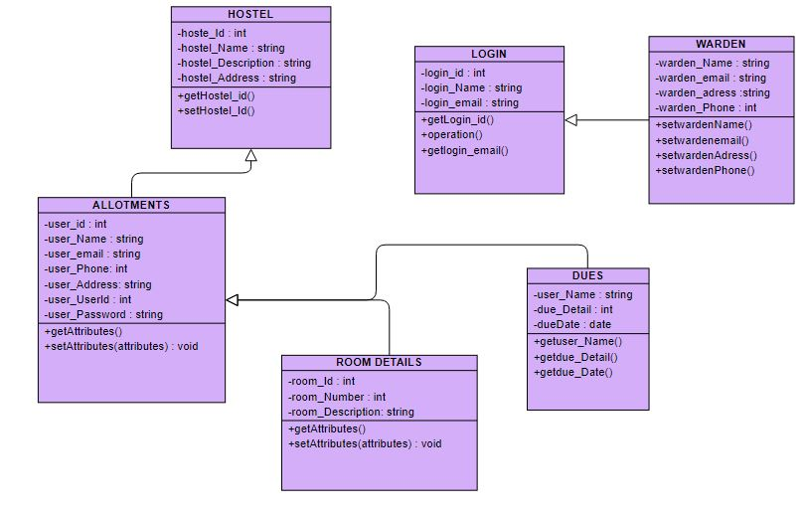

*FIG 20*

**2.4 ASSOCIATION DIAGRAM**

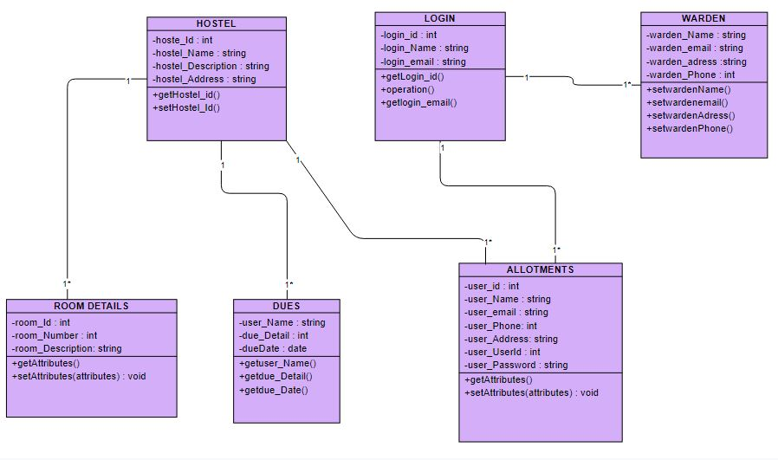

*FIG 21*

**2.5 AGGREGATION DIAGRAM**

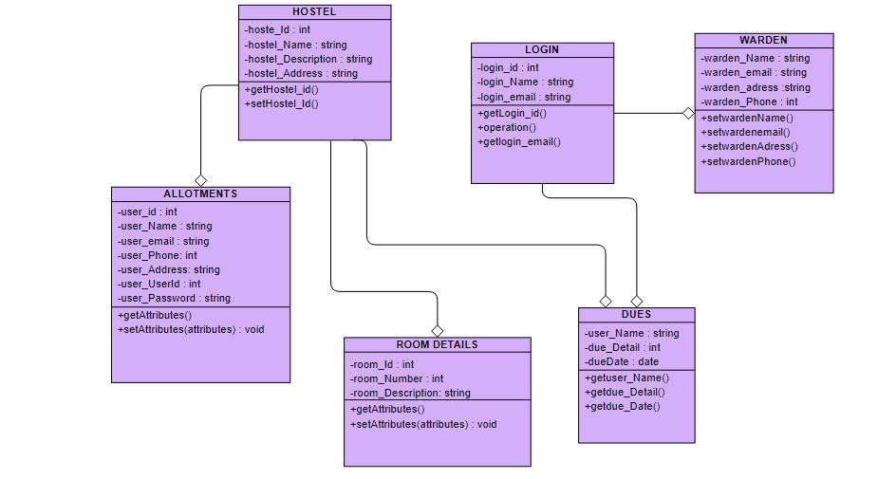

**MODULE 3 : CSE**

**3.2 INDEPENDENT CLASS DIAGRAM**

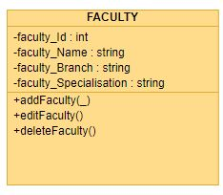

*FIG 22 FACULTY CLASS*

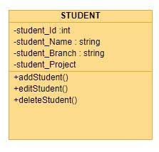

*FIG 23 STUDENT CLASS*

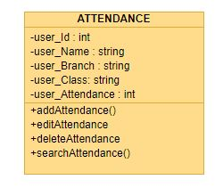

*FIG 24 ATTENDANCE CLASS*

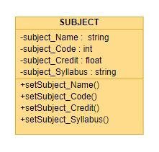

*FIG 25 SUBJECT CLASS*

3.3 SUPER-SUB CLASS DIAGRAM

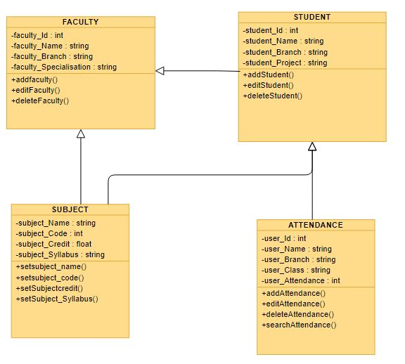

*FIG 26*

**3.4 ASSOCIATION DIAGRAM**

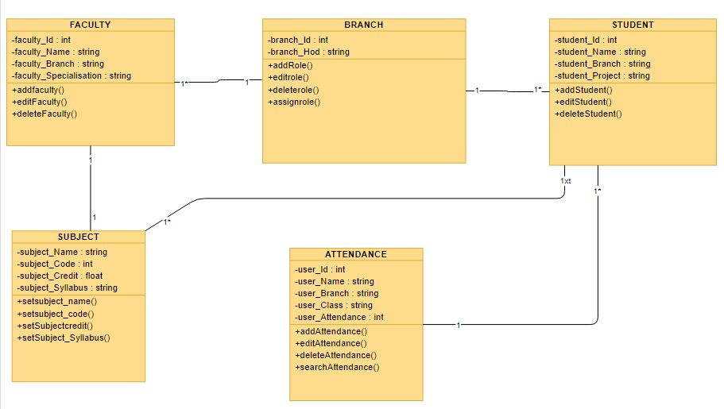

*FIG 26*

**3.5 AGGREGATION DIAGRAM**

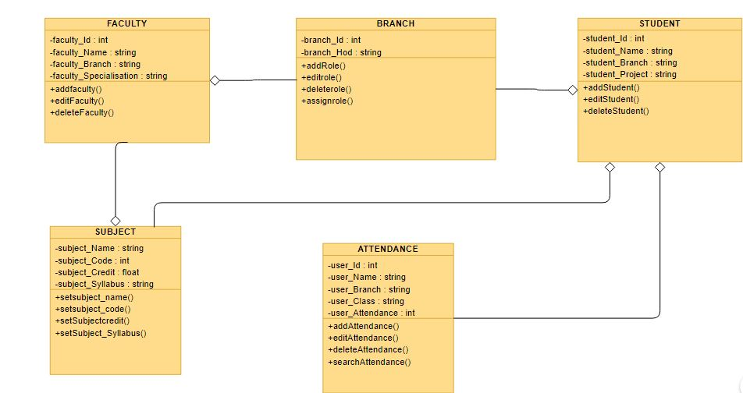

**MODULE 4 :ERP**

**4.2 INDEPENDENT CLASS DIAGRAM FOR ERP MODULE**

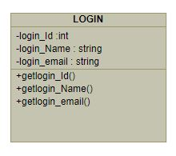

*FIG 27 LOGIN CLASS*

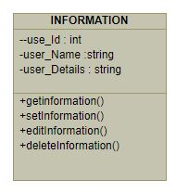

*FIG 28 INFORMATION CLASS*

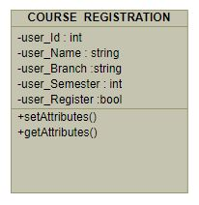

*FIG 29 COURSE REGISTRATION CLASS*

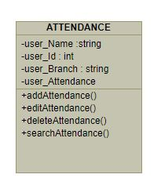

*FIG 30 ATTENDANCE CLASS*

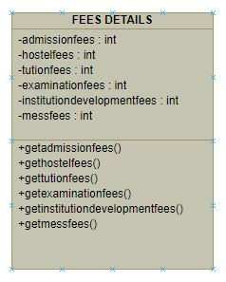

*FIG 31 FEES CLASS*

**4.3 SUPER-SUB CLASS DIAGRAM**

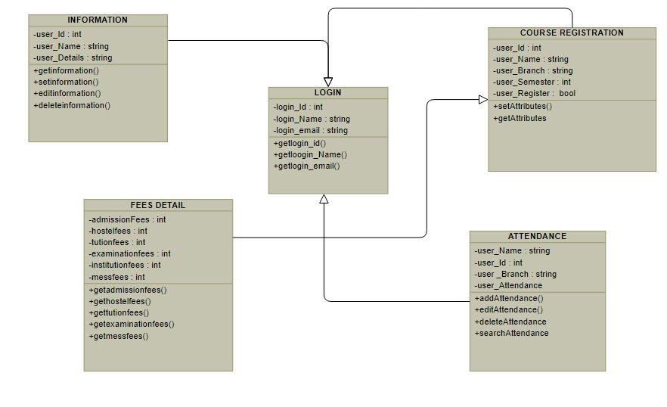

*FIG 32*

**4.4 ASSOCIATION DIAGRAM**

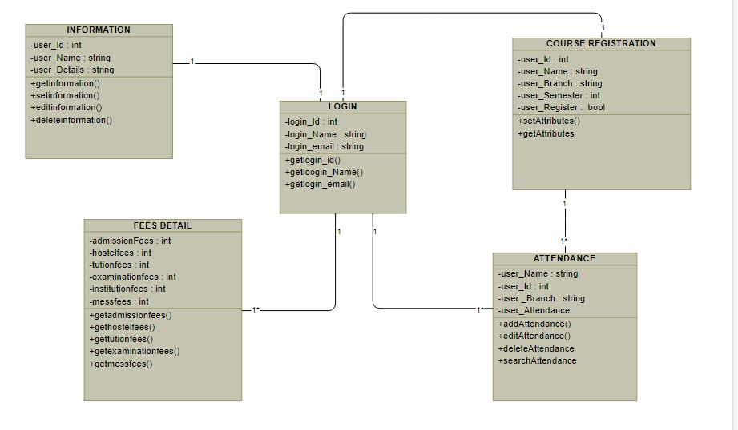

* *FIG 33*

**4.5 AGGREGATION DIAGRAM**

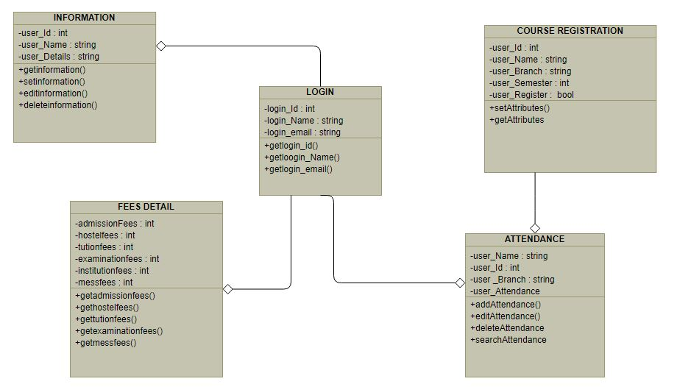

**THANK-YOU**